Software Requirements Specification

Requirements Specification for App in Medical Application Platforms

Version 1.0

<<Annotated Version>>

June 19, 2021

إعداد:

* بتول أسعد فئة رابعة
* اليسار بدور فئة رابعة
* ياسمين العكاري فئة رابعة

<<Any comments inside double brackets such as these are not part of this SRS but are comments upon this SRS example to help the reader understand the point being made.

Refer to the SRS Template for details on the purpose and rules for each section of this document.

The two students presented this work as a project for the fourth year of the software department

The project works on the Android platform, providing medical services to people and helping doctors and medical centers display their information and sites >>

# 0.1 Table of Contents

0.1. Table of Contents 2

0.2. List of Figures 3

1.0. Introduction .4

1.1. Purpose **4**

1.2. Scope of Project 4

1.3. Glossary **4.**

1.4. References **5.**

1.5. Overview of Document **5.**

2.0. Overall Description 6.

2.1 System Environment **6.**

2.2 Functional Requirements Specification 7

2**.**2**.**1User Use Case **7**

2.2.1.2 Use case: View **7.**

2.2.1.2 Use case: Search **7.**

2.2.2 Doctor Use Case 8

2.2.2.1 Use case: Sign in 9

2.2.2.2 Use case: Sign up 9

Use case: Update 9

2.2.3 Admin Use Case **11**

2.2.3.1 Use case: Sign in **11**

2.2.3.2 Use case: Sign up **11**

2.2.3.3 Use case: Update **11**

2.2.3.4 Use case: Remove **11**

2.3 User Characteristics **13.**

2.4 Non-Functional Requirements **13**

3.0. Requirements Specification 13.

3.1 External Interface Requirements **14**

3.2 Functional Requirements **14**

3.2.1 View **14**

3.2.2 Search **14**

3.2.3 Sign in Doctor/Admin **15**

3.2.4 Sign up Doctor/Admin **15.**

3.2.5 Update Doctor/Admin **16.**

3.2.6 Remove Doctor/Admin **16.**

3.3 Detailed Non-Functional Requirements **17**

3.3.1 Logical Structure of the Data **17**

3.3.2 Security **19**

Index 20

# 0.2 List of Figures

Figure 1 - System Environment 6**.**

Figure 2 - Logical Structure of the Article Manager Data 17

# Introduction

## Purpose

The purpose of this document is to present a detailed description of the Android Application System. It will explain the purpose and features of the system, the interfaces of the system, what the system will do, the constraints under which it must operate and how the system will react to external stimuli. This document is intended for both the stakeholders and the developers of the system and will be proposed to the collage As a project for the fourth year software department.

## 1.2 . Scope of Project

The goal of this project is to build a customer / server application running on the Android platform to allow the user to facilitate the finding of medical places within the government of Homs

The user will browse and search for medical facilities in this city.

The search can be by region or service required

The registrants can update their data and the admin can control the accounts (remove, update).

### 1.3. Glossary

|  |  |
| --- | --- |
| Acronyms / Definitions / Terms | Description |
| Database | Collection of all the information monitored by this system. |
| Admin | Application Developer |
| Doctor | the services provided by the application for example pharmacy, doctors, hospitals and medical centers |
|  |  |
| View | Review the types of services provided and their locations |
| Search | Looking for the required service so that it is closest to its location |
| App | Shortcut is intended to application your doctor here |
| Sign in | The doctor, hospital, or medical center is registered with the application |
| Sign up | The doctor, hospital, pharmacy or medical center send the request for registration by application... |
| Information | Personal data of the doctor, hospital, pharmacy or medical center ( name, telephone number, location and specialty) |
| Account | A special account for each application registrant that includes personal data and gives it the possibility of modification |
| ID | A number given by the administrator for easy deletion, filtering or modification... |
|  |  |
| Stakeholders | Any person with an interest in the project who is not a developer. |

## 1.4. Reference Documents

IEEE. IEEE Std 830-1998 IEEE Recommended Practice for Software Requirements Specifications. Internet

## 1.5. Overview of Document

The following section, the General Description section, of this document provides an overview of the functionality of the application. Describes informal requirements and is used to create a context for specification of technical requirements in the next chapter.

Chapter III, section requirements specifications, of this document is written primarily for developers and technically describes the details of the application function.

Both sections of the document describe the entire program product itself, but are intended for different audiences, and therefore use a different language

# Overall Description

2.1 System Environment

Contains a detailed description of the medical system that explains the purpose of the system and its features and the constraints under which it must operate

The system provides a user interface that can be used to search for its target. It also allows doctors and medical centers to publish their detailed information by registering with the application. This is done after the manager approves their request after verifying their information.

<<The system divides into two parts a user looking for a medical service and a Doctor that provides his information and location on the application to make it easier for the user to choose and determine his request. is an example of using domain classes to make an explanation clearer. >>

Application

App Manager

DB

Admin

Doctor

User

**Figure 1 - System Environment**

## 2.2 Functional Requirements Specification

This section outlines the use cases for each of the active Actors .

The user has two use case view and search .

### 2.2.1 User Use Case

The User has the following sets of use cases:

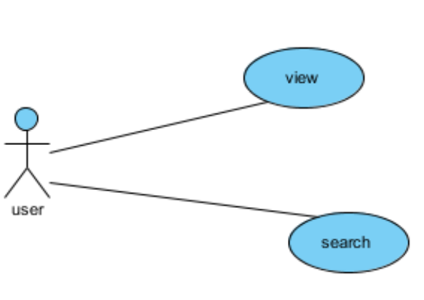

2.2.1.1 View use cases

Use case : View

Diagram

User

View

**Brief Description**

The user browses the application interface the doctors and reads their profile information and sites

**Initial Step-By-Step Description**

Before this use case can be initiated The user loads the application on their mobile device

1. He logs on with his own email
2. A user browser his request according to the nearest to his region.

**Xref:** Section 3.2.1, View

2.2.1.2 Use case name: Search

Diagram

User

Search

**Brief Description**

The user search through the application interface doctors and reads their profile information and sites

**Initial Step-By-Step Description**

Before this use case can be initiated The user loads the application on their mobile device

1. He logs on with his own email
2. Looking for a doctor or a specific medical center
3. Look for a doctor or medical center are closet to him

**Xref:** Section 3.2.2, Search

### Doctor Use Case

In this use case for multiple users, is described the users pharmacy, doctors, hospitals and medical centers where he is registered enters his own information and location and he can updates his information

. 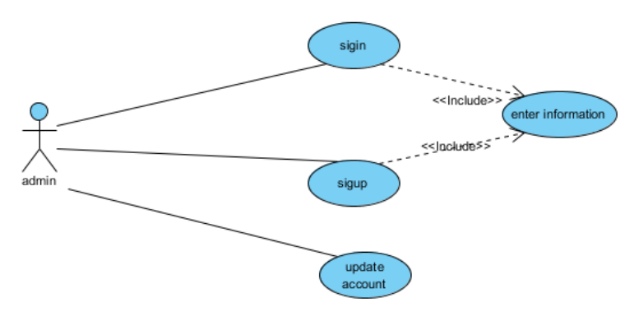

Doctor

#### 

#### 2.2.2.1 Use case: Doctor sign in

**Diagram:**

Doctor

Sign in

**Brief Description**

### Describes the entry of the user (doctor, pharmacy, hospital or medical center) so that he is previously registered in app database

**Initial Step-By-Step Description**

Before you start using the state of use, the user has uploaded the application to their device

1. log in
2. sign out

**Xref:** Section 3.2.3,

**Diagram** :

#### 2.2.2.2 Use case: Doctor sign up

Sign up

Doctor

**Brief Description**

### Describes the entry of the user (doctor, pharmacist or medical center) And send his personal data (name, phone and location…) to be stored at the Database after verification by the Admin

**Initial Step-By-Step Description**

Before you start using the state of use, the user has uploaded the application to their device

1. Send his personal information (name and telephone number)
2. Determines its specialization
3. Determines his location

**Xref:** Section 3.2.4, sign up

#### 2.2.2.3 Use case: Doctor update

**Diagram:**

Update Reviewer

Doctor

**Brief Description**

### Describes the entry of the user (doctor, pharmacist or medical center) so that he is previously registered in Database And modify his data when it has any change

**Initial Step-By-Step Description**

Before you start using the state of use, the user has uploaded the application to their device

1. log in
2. modify his data
3. send his new data
4. sign out

**Xref:** Section 3.2.5,

### Admin Use Case

this use case for Admin the application Describes the work of the application Admin who can accept register by the (doctor or medical center) after checking the validity of his information and deleting accounts

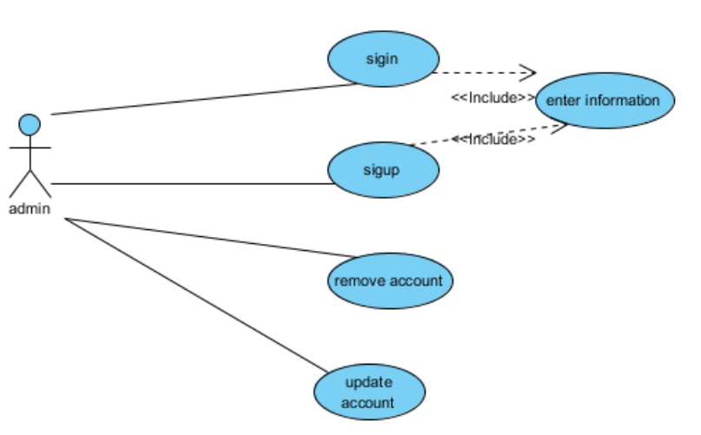

#### 2.2.3.1 Use case: Admin sign in

**Diagram:**

Admin

Sign in

**Brief Description**

Describes the sign-in process by the Admin

**Initial Step-By-Step Description**

Before this situation begins, the administrator has finished application development and is ready to use

1. Log in using his username and password
2. Create new accounts
3. Grant a special ID to users (doctor and clinic) to activate the account after confirming their identity

**Xref:** Section 3.2.3,

#### 2.2.3.2 Use case: Admin sign up

**Diagram:**

Admin

Sign up

**Brief Description**

Describes the sign-up process by the Admin

**Initial Step-By-Step Description**

Before this situation begins, the administrator has finished application development and is ready to use

1. Create username and password for him

**Xref:** Section 3.2.4

#### 2.2.3.3 Use case: Admin update

**Diagram:**

Admin

update account

**Brief Description**

Describes the update account process by the Admin

**Initial Step-By-Step Description**

Before this situation begins, the administrator has finished application development and is ready to use and create his account

1. Updating previously registered information in the database after sending the user new information

**Xref:** Section 3.2.5,

#### 2.2.3.4 Use case: Admin remove

**Diagram:**

Admin

remove account

**Brief Description**

Describes the remove account process by the Admin

**Initial Step-By-Step Description**

Before this situation begins, the administrator has finished application development and is ready to use and create his account

1. Remove previously registered information in the database

**Xref:** Section 3.2.6

## User Characteristics

The User is expected to be Internet literate and be able to use a search engine to download the application. The interface of application will be easy to user and doctor

The detailed look of these pages is discussed in section 3.2 below.

## Non-Functional Requirements

* Access to the system allows (Normal user) just access the system and review the content
* It should work on more than one version of Android
* The application interface should be easy and clear to users

# Requirements Specification

## 3.1 External Interface Requirements

The only link to an external system is the link to the Database to verify doctor. The Admin Checks the data and gives the user ID (doctor or medical center)

The user doctor sends his data to the admin to verify that it is correct . When checked, it is saved to the database so that the user can view it.

## 3.2 Functional Requirements

The Logical Structure of the Data is contained in Section 3.3.1.

### 3.2.1 View

|  |  |
| --- | --- |
| **Use Case Name** | View use case |
| **XRef** | Section 2.2.1.1, View |
| **Trigger** | The User assesses the interface application |
| **Precondition** | The Application is displayed with interface for view and The interface is easy to use by the user |
| **Basic Path** | 1. Browse user services provided and specifications.  2. When choosing any type of previous species  3. The user can select the closest to him  4. User selects service  5. The system displays a summary for each doctor |
| **Other** | A list is created to sort the specifications |

### 3.2.2 Search

|  |  |
| --- | --- |
| **Use Case Name** | Search use case |
| **XRef** | Section 2.2.1.2, Search |
| **Trigger** | The User assesses the interface application |
| **Precondition** | The Application is displayed with interface for search and The interface is easy to use by the user |
| **Basic Path** | 1. The user searches for his request through the search box.  2. When choosing any type of previous species  3. The user can select the closest to him  4. User selects service  5. The system displays a summary for each doctor |
| **Alternative Paths** | In step 3, if the User selects to search by closest to him , the system creates and presents a list of all doctors in the database.   1. The user selects a service. 2. The system creates and presents a list of all Doctor in that region in the database. Return to step 5. |
| **Exception Paths** | The search can be canceled at any time |
| **Other** | None |

### 3.2.3 Sign in Doctor/Admin

|  |  |
| --- | --- |
| **Use Case Name** | Sign in |
| **XRef** | Section 2.2.2.1, Section2.2.3.1 Sign in |
| **Trigger** | The doctor/admin assesses the interface application |
| **Precondition** | The Application is displayed with interface for signin by username and password |
| **Basic Path** | 1.The doctor or admin logs in by name and password  2. After logging in, the Doctor can control and update his account  3. After logging in by admin he can update or deletes |
| **Exception Paths** | The login process can end at any moment |
| **Other** | none. |

### 3.2.4 Sign up Doctor/Admin

|  |  |
| --- | --- |
| **Use Case Name** | Sign up |
| **XRef** | Section 2.2.2.2, Section 2.2.3.2 |
| **Trigger** | The doctor/admin assesses the interface application |
| **Precondition** | The Application is displayed with interface for doctor can send his information |
| **Basic Path** | 1. The doctor sends his personal information to subscribe to the application 2. The admin makes sure that the information is correct 3. The registration request is accepted and the Doctor can update his information 4. Admin When you develop an application, he creates a special account with a name and password |
| **Exception Paths** | The logon process can end at any moment |
| **Other** | none |

### 3.2.5 Update Doctor/Admin

|  |  |
| --- | --- |
| **Use Case Name** | Update |
| **XRef** | Section 2.2.2.3, Section 2.2.3.3 |
| **Trigger** | The doctor/admin assesses the interface application |
| **Precondition** | The Application is displayed with interface for doctor can send his new information |
| **Basic Path** | 1. The doctor sends his new personal information . 2. The admin makes sure that the information is correct and update database. |
| **Exception Paths** | The update process can end at any moment |
| **Other** | None |

### 3.2.6 Remove Admin

|  |  |
| --- | --- |
| **Use Case Name** | Remove use case |
| **XRef** | Section 2.2.3.4 |
| **Trigger** | The admin assesses the interface application |
| **Precondition** | The Application is displayed with interface for Admin can delete any account |
| **Basic Path** | 1. A Admin will delete an account when his information is incorrect 2. The Admin delete any account at the request of the doctor |
| **Exception Paths** | The remove process can end at any moment |
| **Other** | None |

## 3.3 Detailed Non-Functional Requirements

### 3.3.1 Logical Structure of the Data

The logical structure of the data to be stored in the Database

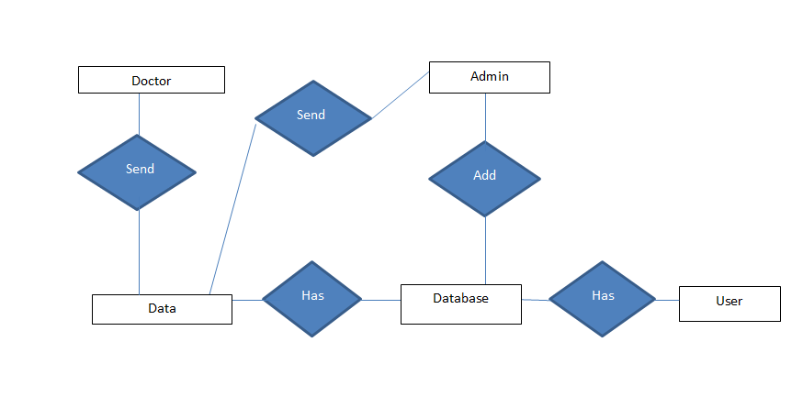

Figure 2 - Logical Structure of the Data

The data descriptions of each of these data entities is as follows:

**Doctor Data Entity:**

|  |  |  |  |
| --- | --- | --- | --- |
| :**Data Item** | **Type** | **Description** | **Comment** |
| Name | Text | Name of the doctor |  |
| ID | Integer | Each doctor registered with the application has his own ID number | Primary number |
| Address | Text | Doctor's Full address |  |
| Phone | Integer | Mobile number or clinic number | Possible for the doctor more than a number |
| Password | Text | Special login number |  |
| Specialty | Text | Specialty doctor | Possible for the doctor more than a Specialty |
| Region | Text | The name of the region |  |
| PM | Integer | Closing hours |  |
| AM | Integer | Opening hours |  |
| Gender | Text | male or female |  |

**Medical Center or Hospital or Pharmacy Data Entity:**

|  |  |  |  |
| --- | --- | --- | --- |
| :**Data Item** | **Type** | **Description** | **Comment** |
| Name | Text | Name of hospital or clinic or pharmacy |  |
| ID | Integer | Each type registered on the application has his own ID number | Primary Key |
| Address | Text | hospital or clinic or pharmacy address |  |
| Type | Text | hospital or clinic or pharmacy |  |
| Password | Text | Special login number |  |
| Region | Text | The name of the region |  |

**Admin:**

|  |  |  |  |
| --- | --- | --- | --- |
| **Data Item** | **Type** | **Description** | **Comment** |
| name | Text | Name of developer |  |
| password | Text | Special login number | Single reviewer |

### Security

### The server on which the Database will have its own security to prevent unauthorized write / delete access. There is no restriction on search and view access.

### The admin will have its own security. Only the Admin will have physical access to the Database

# Support

The internet and Previous Applications

# Index

Database,4,8,9,10,13,16,18,

Admin,2,4,5,8,10,13,14,15,16,18

Doctor,2,3,4,5,6,7,8,9,10,12,13,14,16

sign up,2,4,9,11,15

sign in,2,4,8,11,15

account,4,10,14,16

search,2,3,4,5,6,12,14,18

view,2,4,6,8,12,14,15,16,18

Security, 2,18,19

update,2,4,8,11,15

User, 2,4,6,7,8,9,10,11,12,13,14,15